MANDATORY COURSE PROJECT

Integrated Case Study:
Biotechniques in Action
Diagnostic Investigation of an Unknown Viral Pathogen

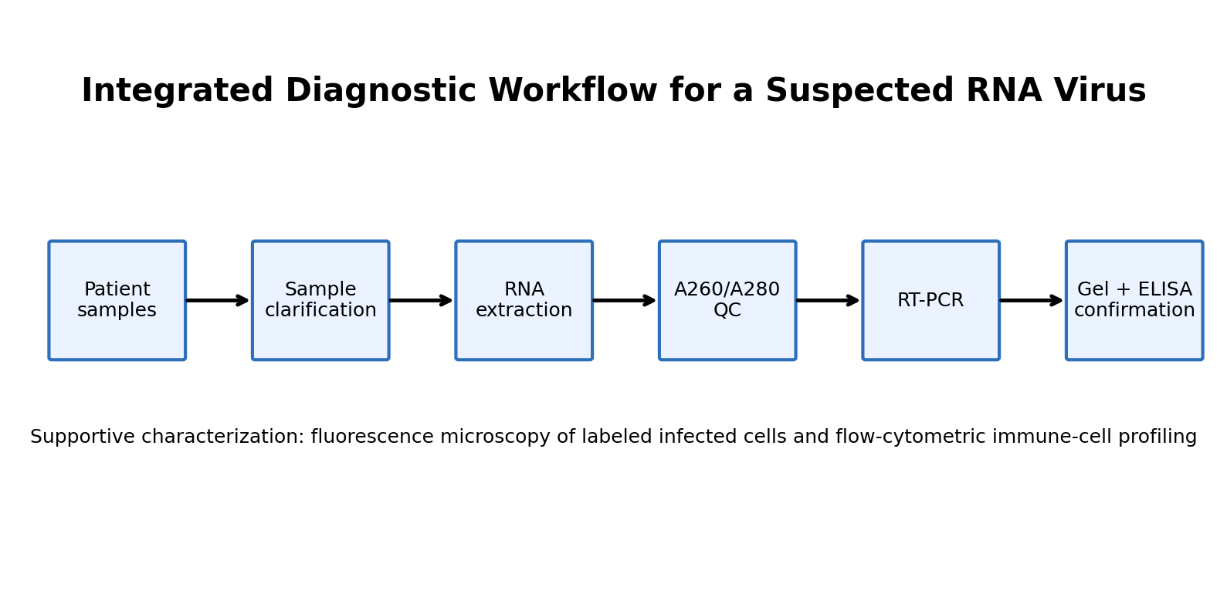
1. Executive Summary
2. Case Study Scenario and Working Assumption
3. Pathogen Selection & Technique Justification
4. Diagnostic Workflow
4.1 Day 1 – Sample Processing and Technique Selection
4.2 Day 2 – Molecular Detection Workflow
4.3 Day 3 – Protein Detection and Immunological Confirmation
4.4 Supportive Characterization Using Microscopy and Flow Cytometry
5. Expected Results & Interpretation
6. Limitations & Troubleshooting
7. Integrated 5-Day Action Plan
8. Conclusion
9. Source Integration and References

1. Executive Summary
An outbreak of severe respiratory illness has been reported in a local hospital, while routine rapid tests for common influenza strains are negative. For this case study, the unknown pathogen is assumed to be an RNA virus. The diagnostic strategy therefore focuses on recovery and quality assessment of viral RNA, reverse-transcription polymerase chain reaction (RT-PCR) for molecular detection, and antibody-based confirmation using an indirect ELISA. A Western blot is proposed as an additional protein-level confirmation when the size of a viral protein must be demonstrated.
The supplied course material strengthens the workflow at three important points. The microscopy module explains resolution, fluorescence and targeted visualization; the spectrophotometry module provides the basis for measuring nucleic-acid absorbance at 260 nm and assessing purity using the 260/280 ratio; and the flow-cytometry module explains fluorescence labeling, light scatter and gating for supportive immune-cell analysis.
The final workflow is intentionally staged: sample clarification/concentration → RNA extraction → spectrophotometric quality control → RT-PCR → agarose-gel analysis → indirect ELISA → optional Western blot → supportive fluorescence microscopy/flow cytometry. A positive molecular result combined with appropriate immunological confirmation would provide substantially stronger evidence than any single assay alone.

2. Case Study Scenario and Working Assumption

2.1 Scenario
The project brief describes a sudden cluster of patients with severe respiratory distress, high fever and fatigue. Routine rapid tests for common flu strains are negative. Patient material consisting of blood serum and throat swabs has been submitted to a biotechnology laboratory. The assignment asks the clinical biotechnologist to design a complete workflow to isolate, detect and confirm the suspected pathogen.

2.2 Working assumption: RNA virus
An RNA virus is selected for this report. This choice determines the molecular workflow because the viral RNA must first be converted into complementary DNA (cDNA) before conventional PCR amplification can be performed.
Decision | Choice | Reason
Genome type | RNA virus | Allows the report to demonstrate an RT-PCR workflow as specifically requested by the project.
Primary sample for molecular test | Throat swab | Directly represents the respiratory site and is suitable for viral nucleic-acid detection.
Serum role | Antibody/protein confirmation | Used for indirect ELISA and, where required, protein-level confirmation.
Primary molecular test | RT-PCR | Detects an RNA target after reverse transcription to cDNA.
Immunological test | Indirect ELISA | Designed to detect patient antibodies against a selected viral antigen.
Protein confirmation | Western blot | Used when the exact size of a viral protein must be demonstrated.

3. Pathogen Selection & Technique Justification
The workflow is designed so that each technique answers a different diagnostic question. Sample preparation reduces interfering material; spectrophotometry checks whether the extracted nucleic acid is suitable for downstream work; RT-PCR asks whether the viral genetic target is present; ELISA asks whether the patient has antibodies that recognize viral antigen; and Western blot provides a size-resolved protein confirmation.
Technique | Role in this case | Justification
Differential centrifugation / clarification | Prepare serum and swab material; remove debris; optionally concentrate viral material. | Separates components according to sedimentation behavior. For serum, clarification is especially useful because serum is already largely cell-free.
Affinity chromatography | Purify a specific viral protein if a suitable binding ligand is available. | Affinity purification is selective because the target protein binds a specific ligand. If no specific ligand exists for a novel virus, a less selective method would be more practical.
UV–Vis spectrophotometry | Quantify and assess purity of extracted RNA. | The supplied module states that DNA and RNA absorb UV strongly and peak at 260 nm; the 260/280 ratio is used as a purity indicator.
RT-PCR | Primary molecular detection. | RNA is reverse-transcribed to cDNA and the target sequence is amplified.
Indirect ELISA | Detect patient antibodies against viral antigen. | Patient serum is tested for antibodies that bind immobilized viral antigen; an enzyme-linked secondary antibody produces the measurable signal.
Western blot | Confirm a viral protein and its approximate molecular size. | SDS-PAGE separates proteins by size before transfer to a membrane and antibody detection.
Fluorescence microscopy | Supportive visualization of labeled viral antigens/infected cells. | The microscopy module describes targeted fluorescence using fluorophores and optical filtering. Standard light microscopy does not directly resolve individual virions.
Flow cytometry | Supportive immune-cell profiling. | The module describes FSC/SSC, fluorescence labeling and gating, allowing selected immune-cell populations to be analyzed.

4. Diagnostic Workflow
Figure 2. Integrated workflow from patient samples to molecular and immunological confirmation.

4.1 Day 1 – Sample Processing and Technique Selection

A. Sample receipt and initial handling
- Receive the throat swab and blood serum with appropriate sample identification and documentation.
- Keep the samples under the laboratory conditions specified by the validated diagnostic SOP and minimize unnecessary handling.
- Separate the workflow into a molecular-testing path and a serum-based immunological confirmation path.
- Use centrifugation primarily for clarification/removal of debris; if viral concentration is specifically required, a validated higher-speed concentration method can be used.

B. Centrifugation: RPM versus RCF
RPM (revolutions per minute) describes how fast the rotor turns, whereas RCF (relative centrifugal force, expressed as ×g) describes the actual acceleration applied to the sample. RCF is more useful for comparing centrifugation conditions because the same RPM can produce different forces in rotors with different radii.
RCF = 1.118 × 10⁻⁵ × r(cm) × RPM²
For this case, a differential-centrifugation approach is appropriate: first use a lower-force clarification step to remove large debris, then use a validated concentration step only if the laboratory method requires recovery of viral particles. Because serum is already cell-free compared with whole blood, the objective is clarification/concentration rather than routine cell separation.
Parameter | Meaning | Why it matters
RPM | Rotor rotations per minute | Depends on rotor geometry; not sufficient by itself to compare force between centrifuges.
RCF (×g) | Relative centrifugal force | Reflects the force experienced by the sample and is therefore preferred for reproducible protocols.
Rotor radius (r) | Distance from rotor center to sample | Changes the RCF generated at a given RPM.

C. Chromatography choice for a specific viral protein
Affinity chromatography is the preferred choice when the viral protein and a suitable ligand are known. The target binds selectively to the immobilized ligand while unrelated proteins pass through or are removed during washing. Elution then releases the target protein. For a novel pathogen, however, a suitable ligand may not yet be available; in that situation, ion-exchange chromatography could be considered as a broader purification strategy.
Method | Basis of separation | Use in this case
Ion-exchange | Charge interactions | Useful when target charge characteristics are known; less target-specific than affinity.
Size-exclusion | Hydrodynamic size | Useful when molecular-size differences are sufficient; generally lower resolving capacity for some mixtures.
Affinity | Specific binding interaction | Preferred for a known viral protein with an available specific ligand/antibody.

4.2 Day 2 – Molecular Detection Workflow

A. RNA extraction strategy
- Process the respiratory sample using a validated viral-RNA extraction method.
- Lysis releases viral RNA and disrupts particles while reducing nuclease activity.
- Remove proteins, lipids, cellular debris and other inhibitors using the extraction system.
- Bind, wash and elute the RNA according to the validated extraction workflow.
- Keep the purified RNA under conditions that minimize degradation and proceed promptly to quality assessment and RT-PCR.

B. Spectrophotometric quality assessment
The supplied spectrophotometry module explains that nucleic acids absorb ultraviolet light strongly because of the aromatic rings in their bases. It states that DNA and RNA show maximum absorbance at 260 nm. Absorbance at 280 nm is used to assess protein-associated contamination through the 260/280 ratio.
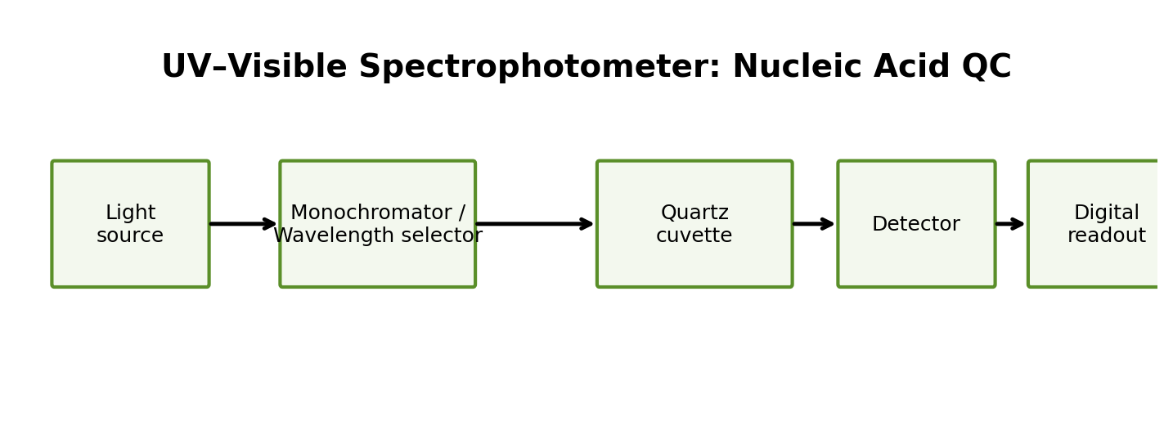
Figure 3. Simplified UV–Visible spectrophotometer path used for nucleic-acid quality assessment.
Measurement | Expected/interpretive value for RNA | Meaning
A260 | Primary nucleic-acid absorbance measurement | Used for nucleic-acid quantification.
A280 | Protein-associated absorbance | Compared with A260 to assess purity.
A260/A280 | ~2.0 for ideal RNA | The supplied spectrophotometry module gives ~2.0 as the ideal RNA ratio.
Low ratio | <~1.7 | Can indicate substantial protein contamination according to the supplied module.
High ratio | >~2.0 | May indicate contamination or sample-composition issues; interpretation should be made with the full extraction context.

The supplied module also gives the Beer–Lambert relationship: absorbance is directly proportional to concentration under appropriate conditions. For RNA, the key point in this project is that A260 provides a quantitative measurement while the A260/A280 ratio provides a rapid purity check.

C. RT-PCR design
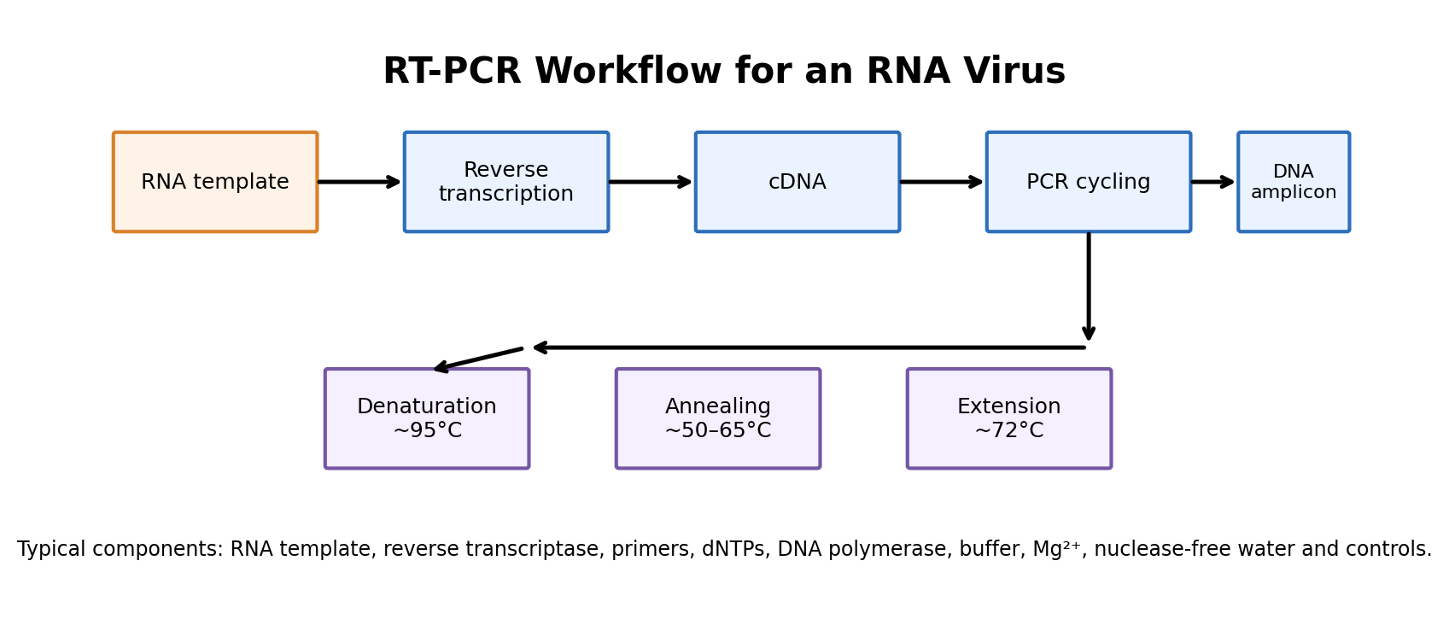
Figure 4. RT-PCR workflow for an assumed RNA virus.
The RT-PCR assay begins with viral RNA. Reverse transcriptase converts the RNA target into cDNA. PCR amplification then uses target-specific primers, a DNA polymerase, nucleotides and appropriate reaction components.
Component | Purpose
Viral RNA template | Contains the suspected viral genetic target.
Reverse transcriptase | Produces cDNA from the RNA template.
Forward and reverse primers | Define the target region to be amplified.
DNA polymerase | Synthesizes new DNA during PCR.
dNTPs | Building blocks for DNA synthesis.
Reaction buffer + Mg²⁺ | Provide suitable chemical conditions for polymerase activity.
Nuclease-free water | Completes reaction volume without adding nucleases.
Positive control | Demonstrates that the assay can amplify a known target.
Negative/no-template control | Helps identify contamination or nonspecific signal.

D. Thermal cycling
- Denaturation: double-stranded cDNA-derived DNA is separated into single strands by heating, commonly around 95°C.
- Annealing: the temperature is lowered so target-specific primers bind to complementary sequences. The exact temperature is primer-dependent.
- Extension: DNA polymerase extends the bound primers, commonly around 72°C for standard thermostable polymerases.
- Repeat the denaturation–annealing–extension cycle for the validated number of cycles so that the target amplicon accumulates to a detectable level.
- Include appropriate controls and interpret the result only after confirming that control reactions behave as expected.

4.3 Day 3 – Protein Detection and Immunological Confirmation

A. Indirect ELISA for patient antibodies
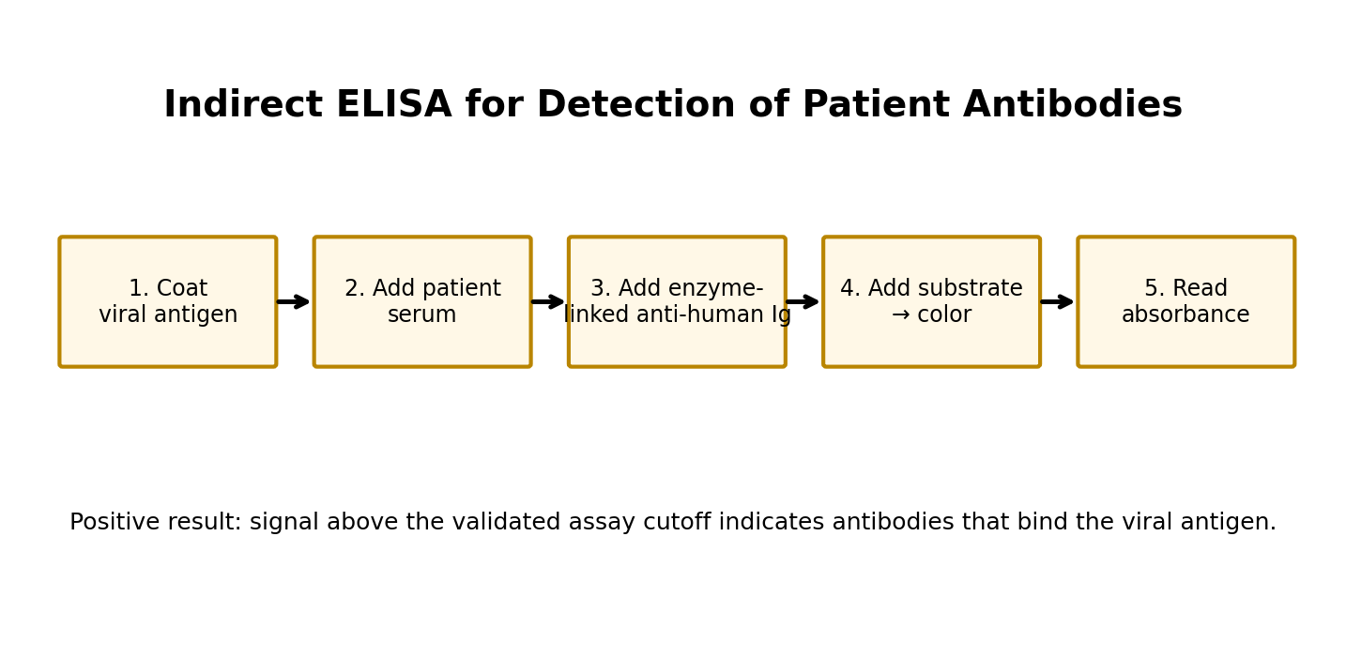
Figure 5. Indirect ELISA concept for detecting antibodies in patient serum.
Indirect ELISA is selected because the question is specifically whether patient serum contains antibodies against the suspected viral pathogen. A viral antigen is immobilized on the plate. Patient serum is added; if specific antibodies are present, they bind the antigen. An enzyme-linked anti-human immunoglobulin secondary antibody then binds the patient antibody. Addition of substrate produces a measurable color signal.
- Coat the wells with a suitable purified viral antigen.
- Block nonspecific binding sites.
- Add patient serum and allow any virus-specific antibodies to bind the antigen.
- Wash to remove unbound serum components.
- Add an enzyme-linked secondary antibody directed against human immunoglobulin.
- Wash again and add the appropriate substrate.
- Measure the generated signal and compare it with validated controls and the assay cutoff.
A positive ELISA result means the sample produced a signal consistent with antibodies that recognize the viral antigen under the assay conditions. It should be interpreted together with controls, cutoff criteria and the molecular result rather than as an isolated diagnosis.

B. Western blot for viral-protein size confirmation
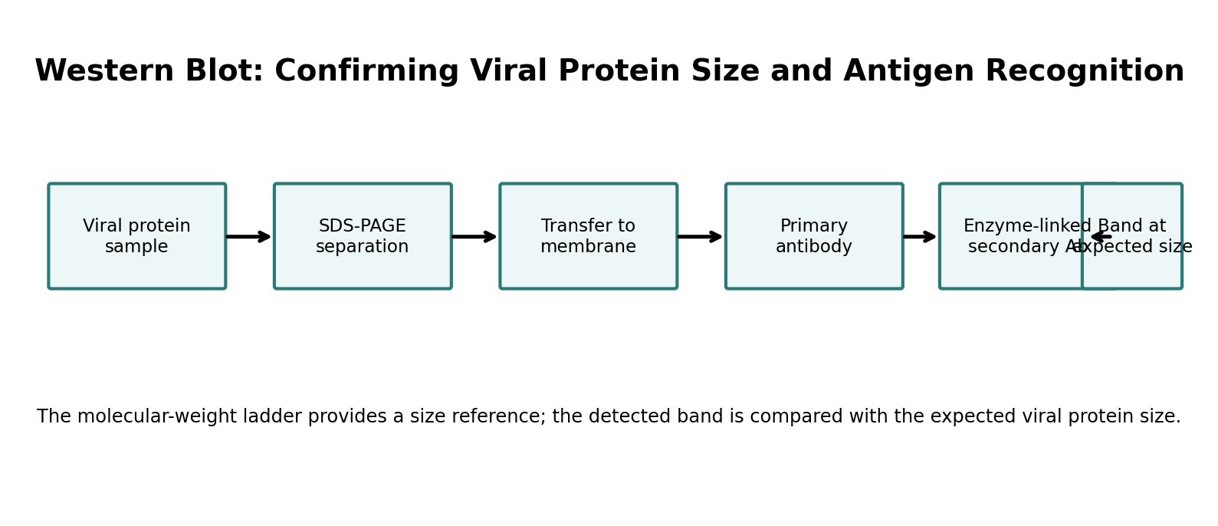
Figure 6. Western blot workflow from protein separation to antibody-based detection.
- Prepare the viral-protein-containing sample for SDS-PAGE.
- Separate proteins according to molecular size by SDS-PAGE alongside a molecular-weight ladder.
- Transfer the separated proteins from the gel to a membrane.
- Block nonspecific binding sites on the membrane.
- Incubate with a primary antibody that recognizes the viral protein.
- Add an enzyme-linked or otherwise detectable secondary antibody.
- Develop the signal and compare the detected band position with the molecular-weight ladder.
The key interpretation is the position of the detected band relative to the molecular-weight ladder. A band at the expected apparent molecular mass, together with appropriate controls, supports identification of the targeted viral protein.

4.4 Supportive Characterization Using Microscopy and Flow Cytometry

A. Fluorescence microscopy
The microscopy module explains that fluorescence microscopy can target specific proteins, DNA or cellular structures using fluorescent antibodies or genetic tags. It also describes the role of excitation filters, dichroic mirrors and emission filtering in separating emitted fluorescence from excitation light.
- Use fluorescence microscopy only as supportive evidence, for example to visualize labeled viral antigen in infected cells.
- Do not treat a conventional bright-field image as direct proof of individual virions; the supplied module places viruses in the nanoscopic scale.
- Compare labeled and control samples to distinguish specific fluorescence from background.

B. Flow cytometry
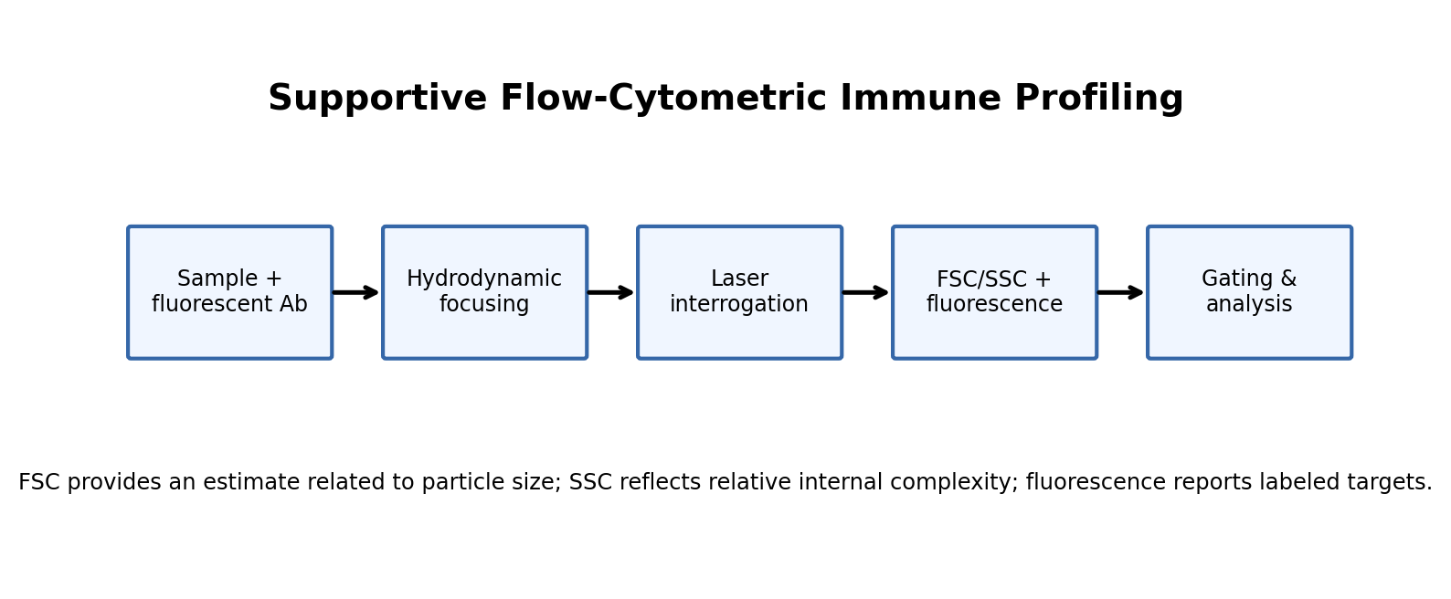
Figure 7. Supportive flow-cytometric immune-cell profiling based on the supplied Day 3 module.
The flow-cytometry module describes three major systems—fluidics, optics and electronics. Hydrodynamic focusing aligns cells in single file; lasers generate scatter and fluorescence signals; and detectors convert optical signals into digital data. Forward scatter (FSC) can provide an estimate related to particle size, while side scatter (SSC) provides information related to internal complexity or granularity. Fluorescent antibodies can identify specific targets, and gating isolates selected cell populations for analysis.
For this case, flow cytometry is supportive rather than the primary viral detection assay. It could be used to characterize immune-cell populations or selected fluorescent markers associated with the host response. The module also notes clinical use in monitoring HIV disease progression by CD4+ T-cell counting, illustrating how flow cytometry can support clinical immunology.

5. Expected Results & Interpretation

5.1 Spectrophotometry
Observation | Expected interpretation
A260 signal present | Nucleic acid is present and can be quantified.
A260/A280 near ~2.0 for RNA | Consistent with the ideal RNA purity value given in the supplied module.
Lower-than-expected ratio | Possible protein or other contaminant; extraction quality should be reviewed.
Poor-quality/very low nucleic-acid signal | Insufficient recovery or degradation should be considered.

5.2 Agarose gel electrophoresis after RT-PCR
If the RT-PCR successfully amplifies the target, a distinct DNA band should appear at the expected amplicon size in the patient lane. The negative control should remain free of the target band, while the positive control should produce the expected band. An unexpected band pattern may indicate nonspecific amplification or other assay problems.
Lane/result | Interpretation
Patient: expected-size band; controls valid | Supports presence of the target sequence.
Patient: no band; positive control valid | Target not detected or assay sensitivity/sample quality was insufficient.
Negative control: target-size band | Suggests contamination; patient result should not be accepted without troubleshooting.
Multiple unexpected bands | May indicate nonspecific amplification or suboptimal primer/cycling conditions.

Role of DNA ladder: The ladder contains DNA fragments of known sizes. It provides a reference for estimating the molecular size of the patient amplicon by comparing migration distance.

5.3 ELISA
A positive indirect ELISA is represented by a signal above the validated cutoff in the patient sample, with acceptable positive and negative controls. This indicates that antibodies in the patient serum recognize the viral antigen used to coat the plate. A negative result indicates that no antibody signal above the assay threshold was detected under the conditions used; it does not by itself exclude early infection or an inadequate immune response.

5.4 Western blot
A supportive Western blot result would show a distinct immunoreactive band at or near the expected apparent molecular mass of the viral protein, with an appropriate molecular-weight ladder and controls.

5.5 Integrated interpretation
Evidence combination | Interpretation
RT-PCR positive + ELISA positive | Strongly supports current/recent infection when controls and clinical context are consistent.
RT-PCR positive + ELISA negative | Could represent early infection, before a detectable antibody response, or an assay sensitivity issue; repeat/orthogonal testing may be appropriate.
RT-PCR negative + ELISA positive | Could reflect prior exposure, later-stage infection, or molecular-test limitations; interpretation depends on timing and clinical context.
Both negative | No target or antibody was detected by these assays; infection is not demonstrated by the tested methods, but pre-analytical and sensitivity limitations should be considered.

6. Limitations & Troubleshooting

6.1 PCR/RT-PCR limitations
- False positive due to contamination of samples, reagents or amplified products. Use physical separation of pre- and post-amplification work, controls and validated procedures.
- False negative due to low viral load, degraded RNA, inefficient extraction, inhibitors, primer mismatch or inadequate assay sensitivity.
- Poor primer specificity can generate nonspecific products, complicating gel interpretation.
- RNA is susceptible to degradation, so sample handling and nuclease control are important.

6.2 ELISA limitations
- False positive signal can occur from nonspecific antibody binding, cross-reactivity or inadequate washing/blocking.
- False negative results can occur when antibody levels are below the detection threshold, particularly early in infection.
- Assay interpretation depends on the validated cutoff and the performance of positive and negative controls.
- Antibody detection indicates an immune response but does not necessarily establish the exact time of infection.

6.3 Troubleshooting decision tree
Problem | Likely cause(s) | Action
No patient RT-PCR band | Low template, RNA degradation, extraction failure, inhibitors | Check extraction control, RNA quality, internal control and assay setup.
Band in negative control | Contamination | Reject affected run, decontaminate workflow and repeat with fresh reagents.
Multiple RT-PCR bands | Nonspecific amplification | Review primer design, annealing conditions and cycling parameters.
High ELISA background | Nonspecific binding / washing problem | Review blocking, washing and reagent conditions.
ELISA positive but RT-PCR negative | Timing, prior exposure or molecular-test limitation | Interpret with clinical timing and consider repeat/orthogonal testing.
Unexpected Western-blot band | Nonspecific antibody binding or sample complexity | Review antibody specificity, controls and molecular-weight reference.

7. Integrated 5-Day Action Plan
Day | Objective | Main activities | Output
Day 1 | Sample processing & technique selection | Clarify/concentrate samples; decide centrifugation strategy; justify RPM vs RCF; select affinity chromatography for a known specific viral protein. | Prepared samples and technique rationale.
Day 2 | Molecular detection | Extract RNA; measure A260/A280; perform RT-PCR with controls; prepare gel analysis. | RNA QC and molecular detection result.
Day 3 | Immunological confirmation | Perform indirect ELISA; if required, separate viral proteins by SDS-PAGE and perform Western blot detection. | Antibody and protein-level evidence.
Day 4 | Results & limitations | Interpret gel bands, DNA ladder, ELISA signal and controls; identify PCR/ELISA limitations and troubleshooting steps. | Integrated interpretation.
Day 5 | Compilation & review | Proofread, check headings and figures, verify that every project question is answered, and finalize the document. | Final project report.

8. Conclusion
For the assumed RNA virus, the most direct diagnostic path is to obtain viral RNA from the respiratory specimen, verify its quality by spectrophotometry, and detect the target using RT-PCR. Serum provides a complementary route for indirect ELISA-based antibody detection. When protein identity and approximate molecular size need additional confirmation, Western blot can provide size-resolved immunological evidence.
The supplied microscopy, spectrophotometry and flow-cytometry modules contribute important supporting principles: microscopy emphasizes the distinction between magnification and resolution and provides the basis for fluorescence visualization; spectrophotometry provides the 260-nm nucleic-acid measurement and the 260/280 purity concept; and flow cytometry provides fluorescence labeling, scatter and gating principles for supportive immune-cell analysis. Together, these techniques form a logical workflow in which molecular, immunological and supportive cellular evidence are interpreted with appropriate controls and awareness of limitations.

9. Source Integration and References

9.1 Project brief
Biotechniques Course Project Final, “Integrated Case Study: Biotechniques in Action,” prepared for Biotechshalaa. The project brief supplies the scenario, five-day action plan, required headings and evaluation criteria.

9.2 Supplied Modules
- Day 1: Microscopy: Biotechniques Course: Fundamentals & Applications, dated 07.09.2026. Used for microscopy principles, resolution, fluorescence microscopy, optical components and nanoscopic scale.
- Day 2: Spectrophotometry: Biotechniques Course: Fundamentals & Applications, dated 08.09.2026. Used for UV–Visible spectrophotometry, Beer–Lambert law, A260/A280 measurements and DNA/RNA analysis.
- Day 3: Flow Cytometry: Biotechniques Course: Fundamentals & Applications, dated 09.09.2026. Used for fluidics, FSC/SSC, fluorescence labeling, compensation, gating and clinical applications.

9.3 Source-to-section map
Report section | Primary supplied source
Microscopy and fluorescence rationale | Day 1: Microscopy
Spectrophotometry and nucleic-acid QC | Day 2: Spectrophotometry
Supportive immune-cell analysis | Day 3: Flow Cytometry
Centrifugation, chromatography, RT-PCR, ELISA, Western blot and agarose-gel interpretation | Required by project brief; not described in detail in the supplied three modules, so standard diagnostic workflow principles are used in this report.

